2020 Safe Roads Competition

Investigate the root cause of a fatality, and prioritize preventive approach, in line with “Vision Zero 2.0 Road Map”

Group 6:

Shrey Shah, Cheng Wang, Sumit Chaudhary, Bibhav Rimal (George Brown College)

Professor:

Richard Boire

Course:

Data Project Capstone

# Analysis 1: Number of People Injured vs. Age Group

The top three age groups prone to major injury are between 20-24, 25-29 and 30-34. The data excludes null value and none-value, it only includes fatal, minimal and minor level injuries.

|  |  |
| --- | --- |
| Age Group | No. of People Injured in a traffic accident |
| 20-24 | 755 |
| 25-29 | 681 |
| 30-34 | 525 |

# Analysis 2: Number of Fatalities vs. Age Group

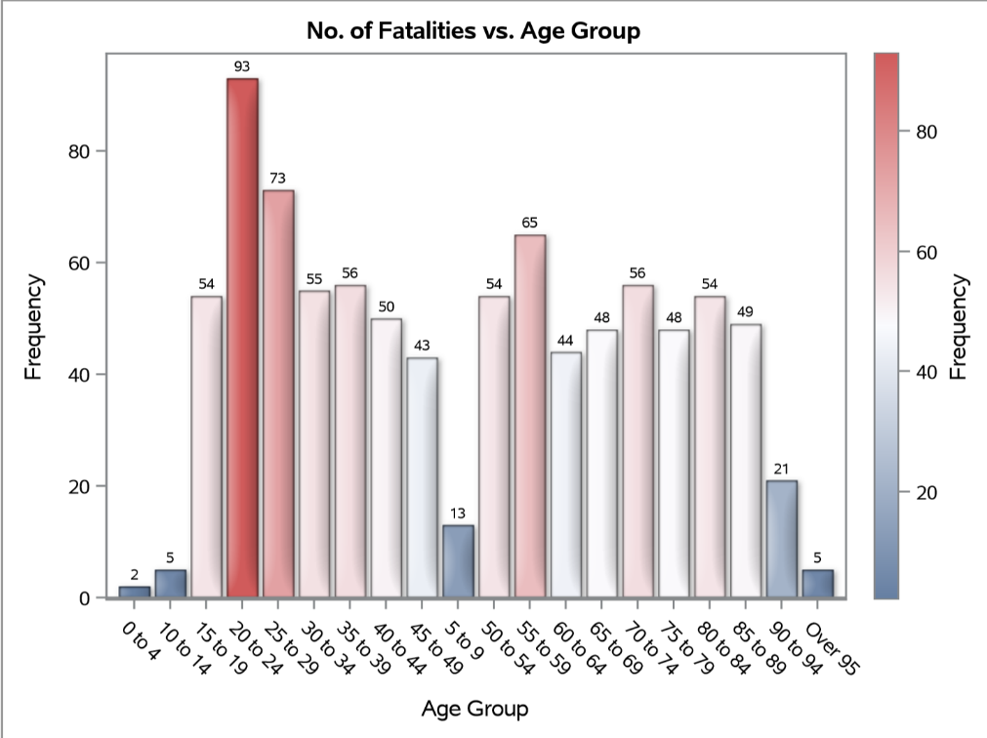Age group of 20-24, 25-29 and 50-54 is the top three group which sustains bodily injuries in death. 93 people have been killed by traffic accident at age group of 20 to 24, 73 people at 25 to 29, and followed by 65 people for age group of 55 to 59. From a criticality based approach, fatality is more severe than injury. Hence, the focus is on fatality.

# Analysis 3: Investigating Type of People Involved in Fatality

The figure beside shows categorization of people in the event of fatality. For the top 3 age groups prone to fatality, driver, pedestrian, and passenger have the top fatality rate. 83 drivers have been killed in an accident and followed by 61 pedestrians and 59 passengers.

## Analysis 3.1: Investigating Effect of Visibility on Fatality

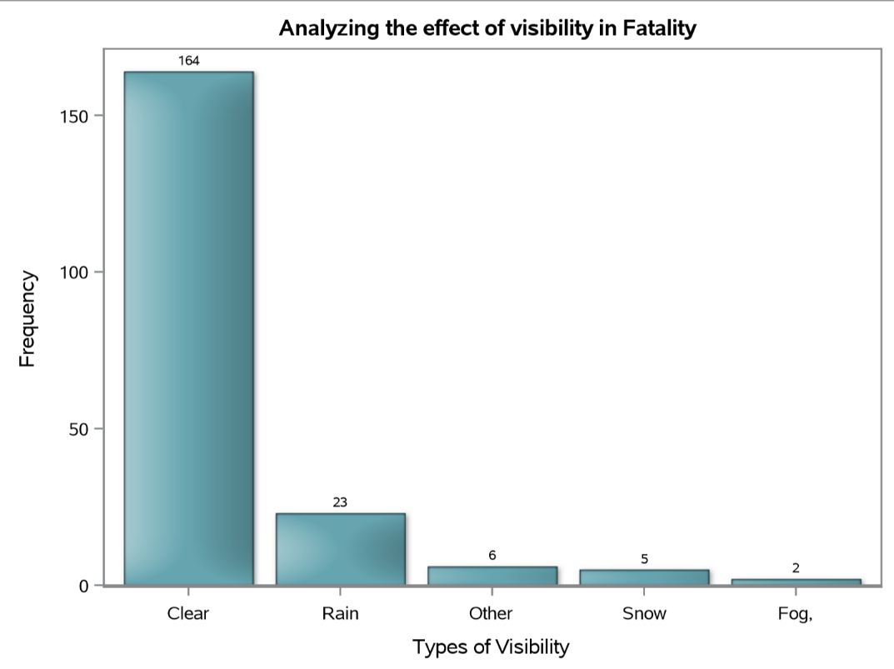164 cases of fatality happened during clear vision, followed by 23 cases in rainy day and 6 cases in other situations. This analysis clarifies that rain and snow is not a contributor for fatality. People might lower their guard when weather condition is great while driving.

## Analysis 3.2: Investigating road conditions and Vehicle type with fatality

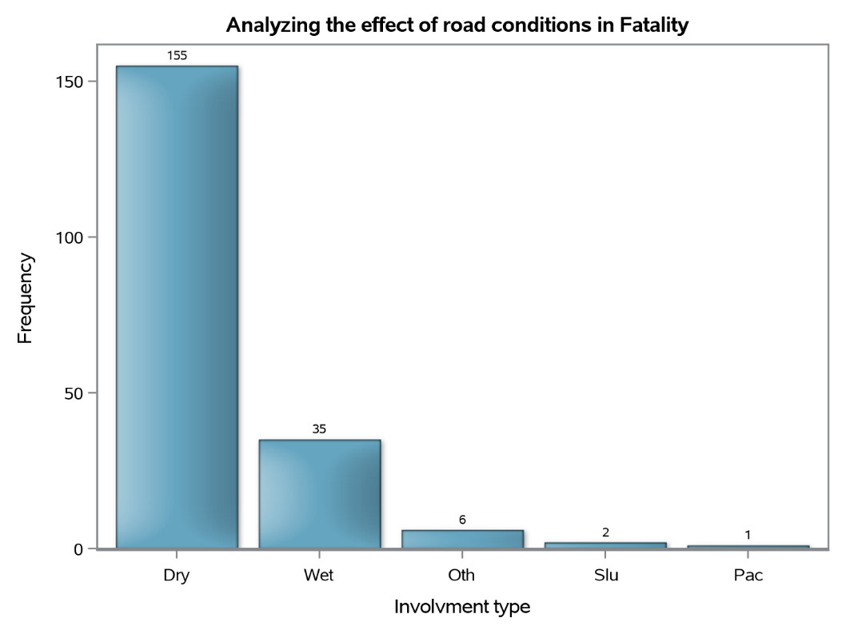Based on the analysis 3.2, 155 traffic deaths happened when the road condition was dry. 35 people got into an accident when the road was wet.

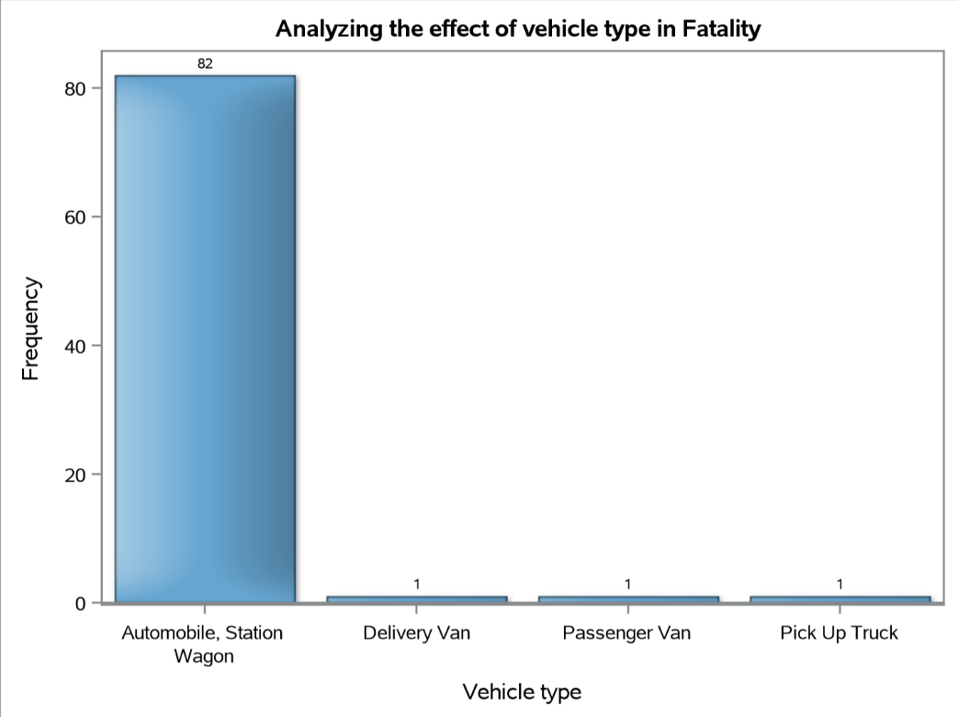The effect of vehicle type with fatality shows that 82 fatal accidents happened when people were driving automobile, station wagon. Only one fatal case for each pickup truck, passenger van and delivery van.

## Analysis 3.3: Investigating Location coordinates with fatality

|  |  |  |
| --- | --- | --- |
|  |  | The effect of road location on fatality shows that 36 cases of fatality is around mid-block and 24 happened in the intersection. |

# Analysis 4: Location and lighting analysis

|  |  |  |
| --- | --- | --- |
| 4.1 Overview of all accidents |  | 4.2 Daylight and No traffic control |
| The figure above is shown all the location which happened fatal accident with top three fatality age group, clear visibility, dry road condition, automobile (station wagon) as vehicle and driver, passenger or pedestrian involved in the accident. |  | The figure above is shown the location which having fatal traffic accident in the daylight and the location has no traffic control. There are 11 cases, and only one is happened in the intersection and rest of the accident happened in the mid-block. 15 people involved in the 11 cases, and there are 8 cases happened in Etobicoke York, 6 cases in Scarborough, and only one in North York. 10 cases involved in speeding problem.  There are 4 big accidents which cause 2 deaths or 1 injured and 1 fatal in each accident. The reason of causing the accident is exceeding speed limit by having drug or drinking, lost control because of inattentive or improper turn. For those location, we suggest installing a stop sign or speeding camera since most of the location are in the mid-block. The situation can be controlled by slow down driver’s speed or warning sign. |
| 4.3 Daylight with traffic signal or stop sign |  | 4.4 Dark, Dark (artificial) or Dust with traffic signal |
| There are 6 fatal cases happened during daytime with traffic signal or stop sign. 3 cases are in Etobicoke York and 3 cases are in North York. There is one case causes one minor injured with one fatal. Most of the cases involved disobeyed traffic control, and one had alcohol over 0.08. For preventing those accident, social media might help us to raise people’s vigilance the consequence of disobeying traffic act by using those accident as an example. |  | According to the figure above, it shows that most of accident happened in intersection at evening or dust with traffic signal which is similar to the condition in the daytime. There are 10 cases and 11 people involved in those cases. 3 drivers are disobeyed traffic control and 2 of them are ability impaired with alcohol. Two drivers exceeded speed limit and had been drinking. 2 cyclists also did drink before the cyclist collisions. Therefore, almost half of the people are drink-driving. The problem can be prevented by using social media as well to remind people how tragic consequence will be when drunk driving. |

|  |  |  |
| --- | --- | --- |
| 4.5 Dark, Dark (artificial) or Dust with no traffic control |  | 4.6 Gardiner Expressway |
| The figure above shown all the cases which happened in the dust and evening time with no traffic control.   * There are 23 cases classified as fatal accident, and 5 cases happened in an intersection, 18 cases are in the mid-block. * 27 people involved in those accidents. 21 people have speeding problem, only one cases for both wrong way on the road and improper lane change. * According to the data, 10 people have been drunk or using drug, and 2 people were inattentive. * There is one big accident happened near Victoria village which had four people involved because of speeding and driving under the influence. Since most of accidents happened because of speeding, the best way to prevent speeding is to increase monitoring efforts. In addition, there is one place need to be pay attention to the safeness which is neat the Lake Shore Blvd and Gardiner express highway since this location had four accidents. |  | |  |  |  |  | | --- | --- | --- | --- | | Drivact | Drivcond | Neighbors | Road Class | | Lost control | Unknow | South Parkdale | Expressway | | Lost control | Unknow | South Parkdale | Major Arterial | | Improper lane change | Inattentive | Mimico | Expressway | | Lost control | Ability impaired | South Parkdale | Expressway |  * All the accidents are happened at evening, and they all have speeding problem * The place might need to install a better lighting system and warning sign for drivers * Speeding camera can be used in this area to enlarge the traffic control strength |

# Recommendations

* Since the “type of involvement” in a fatality is maximum “Driver” related, following preventive measures are recommended:
  + Zero tolerance on drunk driving
  + Reducing the allowable blood alcohol limit while driving
  + Impounding the vehicle for a greater number of days
* As part of increased monitoring, install speeding cameras at locations where maximum fatalities are being reported, especially in Scarborough and in Toronto & East York region.
* Install flashing yellow beacons ahead of mid-block to warn the road users
* Social media, if utilized properly, will help to raise people’s vigilance related to consequences of disobeying traffic rules.
* Explore the concept of “Blood Money” payment by driver, incase, found guilty of causing fatality.

# Appendix 1: SAS Code

proc import datafile = '/home/u42959477/Exper/KSI.csv'

dbms = csv out = KSI replace;

run;

/* Injuries with age distributin */

data KSI;

set KSI;

where (invage <> 'unknown' AND injury <> '' and Injury <> 'None');

run;

title "No. of People injured vs. Age Group ";

proc sgplot data = KSI;

label Invage = 'Age Group';

format Invage;

vbar Invage /datalabel colorstat=freq dataskin=matte;

run;

/* Fatalities with age distributin */

data KSI;

set KSI;

where ACCLASS = 'Fatal';

run;

title " No. of Fatalities vs. Age Group ";

proc sgplot data = KSI;

label Invage = 'Age Group';

format Invage;

vbar Invage /datalabel colorstat=freq dataskin=matte;

run;

/* Involvment type of top 3 fatality age groups */

data KSI;

set KSI;

where (invage = "20 to 24") or (invage = "25 to 29") or (invage = "55 to 59");

run;

title " Involvement type in a Fatality ";

proc sgplot data = KSI;

label Invtype = 'Involvment type';

format Invtype;

vbar Invtype /datalabel categoryorder=respdesc fillattrs=(color=cx66A5A0) dataskin=matte;

run;

/* Analyzing the effect of visibility */

data KSI;

set KSI;

where (invtype = "Driver") or (invtype = "Passenger") or (invtype = "Pedestrian");

run;

title " Analyzing the effect of visibility in Fatality ";

proc sgplot data = KSI;

label visibility = 'Types of Visibility';

format visibility;

vbar visibility /datalabel categoryorder=respdesc fillattrs=(color=cx66A5B0) dataskin=matte;

run;

/* Analyzing the effect of road conditions */

title " Analyzing the effect of road conditions in Fatality ";

proc sgplot data = KSI;

label rdsfcond = 'Involvment type';

format rdsfcond;

vbar rdsfcond /datalabel categoryorder=respdesc fillattrs=(color=cx66A5C0) dataskin=matte;

run;

/* Analyzing the effect of Vehicle type */

data KSI;

set KSI;

where (vehtype <> "") AND (vehtype <> "Other");

run;

title " Analyzing the effect of vehicle type in Fatality ";

proc sgplot data = KSI;

label vehtype = 'Vehicle type';

format vehtype;

vbar vehtype /datalabel categoryorder=respdesc fillattrs=(color=cx66A5D0) dataskin=matte;

run;

/*Road Location on Fatality */

data KSI;

set KSI;

where (vehtype = "Automobile, Station Wagon") and (visibility = "Clear") and (rdsfcond = "Dry") and (loccoord <> "Park, Privat");

run;

title " Road Location on Fatality ";

proc sgplot data = KSI;

label loccoord = 'Vehicle type';

format loccoord;

vbar loccoord /datalabel categoryorder=respdesc fillattrs=(color=cx66A5E0) dataskin=matte;

run;

proc sql;

create table work.ksidata as

select Longitude, Latitude, loccoord, count(latitude) AS totcount format=comma16.

from work.ksi

group by Longitude, Latitude;

data ksimap(rename=(long=x lat=y));

set mapsgfk.canada(drop= x y);

where ID1 in('CA-35');

run;

proc sgmap mapdata=ksimap plotdata=ksidata;

openstreetmap;

bubble x=longitude y=latitude size=totcount/group = loccoord;

run;

# Appendix 2: Decision tree

